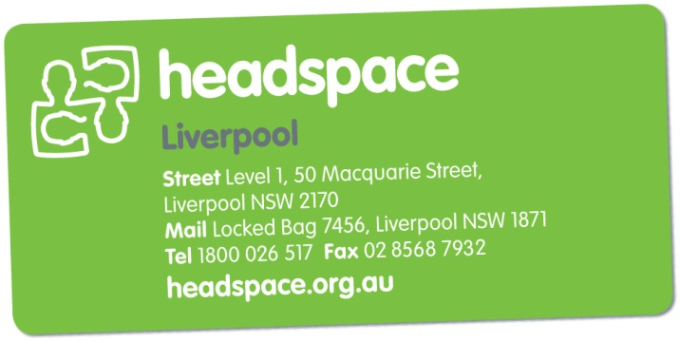
Intake Form

Email to: headspaceliverpool@benevolent.org.au or
Fax referral to: 02 8568 7932

- We strongly recommend anyone referring a Young Person to also call and speak to an intake worker on 1800 026 517. Our opening hours are 8.30am to 5.00pm, Monday to Friday.

- Referrals are considered the week after we receive them. We’ll be in touch after that to offer an appointment or to discuss who might be in a better position to support you / the Young Person.

- We are not an emergency service. If you / the Young Person needs immediate assistance, please call the mental health care line (1800 011 511) or go to the nearest hospital emergency department.

Date:

Who’s referring? ☐ Self ☐ Service provider ☐ Family/friend ☐ Walk-in

Does the YP know about this referral? Yes ☐
If not, the referral cannot be accepted. Please call and we can support you to find other options.
Is the YP between 12 and 25 years of age? Yes ☐
If under 16 years, are the parents/carers aware? Yes ☐

Name
Date of Birth
Gender
Address
Who with? | ☐ At home with family ☐Living alone  ☐ Staying with friends ☐ Homeless  ☐ Refuge ☐ supported accommodation
YP Phone Number
Email (optional)
Name of parent/guardian (optional)

Is YP at school, TAFE, university or working? Yes ☐ No ☐

Where? | Year / Level?

What cultural background does the YP identify as?
Does YP need an interpreter? Yes ☐ No ☐
If ‘Yes’, what language?
Is YP from a refugee background? Yes ☐ No ☐
Is YP of Aboriginal or Torres Strait Islander background? Yes ☐ No ☐

- What’s lead to referring to headspace? What are the current concerns?

- Is the YP at risk of harming themselves or others? Are there any identifiable risk factors? (e.g. thoughts of suicide, self-harm, risk-taking behaviours, harming others)

- Anything else happening that might be affecting the YP? (e.g. family issues, exam stress, issues with friends or relationships)

- Anything from the past that might be affecting the YP now?

- Any previous mental health support / treatment, counselling, medication or diagnoses?

- What does the YP feel would be useful about coming to headspace? How motivated are they to come?

- Any other information that may be relevant? (e.g. family history of mental health issues, court involvement, intellectual disability, physical disability)

Are any of these issues for the YP at the moment?
☐ Physical health ☐ Sexual health ☐ Body image ☐ Alcohol or drugs
☐ Legal issues

Referrer details (if appropriate)
Name | Position / Organisation
Best contact number | Email
Fax | Address

Who is the best person to contact about this referral? ☐ YP
☐ Parent / Guardian
☐ Referrer

Does YP have a GP? Yes ☐ No ☐

GP Name | Medical Centre / Practice

Is there a current Mental Health Treatment Plan? Yes ☐ No ☐

Any other workers/services involved?

Name | Position / Organisation / Contact number

(Office Use Only)
ALLOCATION FOLLOW-UP

