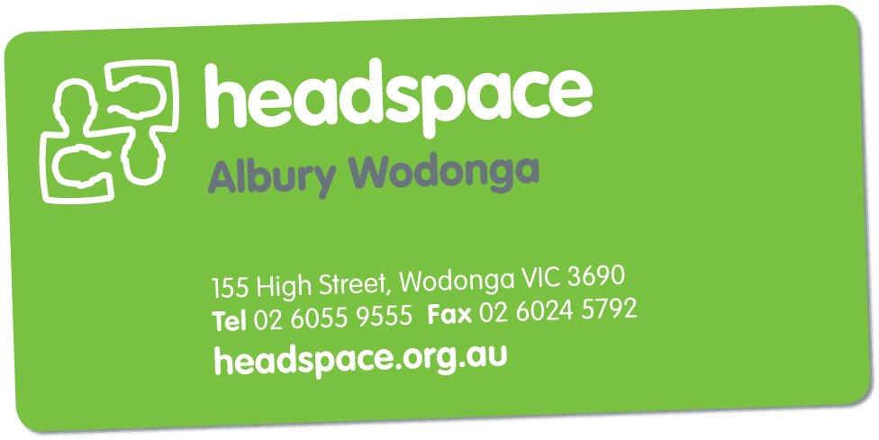
Feedback Form

At headspace Albury Wodonga we welcome and appreciate your feedback so that we can continually improve our service for young people. Please let us know what you thought about your experience at headspace Albury Wodonga.

*Please note that if you wish, you can give your feedback anonymously.

Compliment Complaint Suggestion

Date of Service: ……/……/………….. Staff Member/Service: …………………………………......

Please tell us about your experiences at headspace Albury Wodonga:
………………………………………………………………………………………………………………………………………………………………………………………………………………………………………………………………………………………………………………………………………………………………………………………………………………………………………………………………
Please share your ideas or suggestions with us:
………………………………………………………………………………………………………………………………………………………………………………………………………………………………………………………………………………………………………………………………………………………………………………………………………………………………………………………………A few quick questions:
Would you recommend headspace Albury Wodonga to your friends? Yes No
Will you return to see us if you need to in the future? Yes No
Would you like us to follow up on your feedback? Yes No

If yes, then please provide the information below:

First & Last Name: …………………………………………… Date of Birth: ……/……/…………..
Contact Number: ………………………… Email Address: ………………………………………..
Please either drop this form into the feedback box at reception or send it to:

headspace Albury Wodonga
Gateway Health
155 High Street
Wodonga VIC 3690

