**&**

**5-6 Drinks**

Sensations

Coordination

Judgement

Memory

Vision

Vital Centres

Movement

Reward

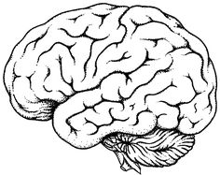

7-8 Drinks

**More than 10 Drinks**

**&**

**9-10 Drinks**

**1-2 Drinks**

3-4 Drinks

-----------------------------------------------