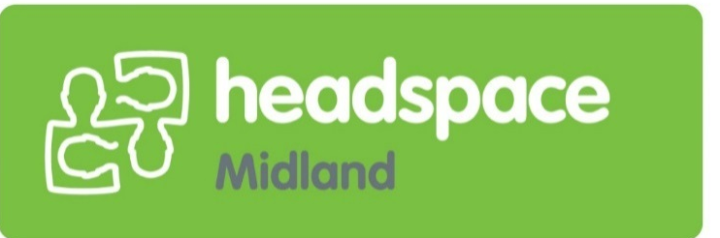

Young Person / Client Information Pack
headspace would like to acknowledge Aboriginal and Torres Strait Islander peoples as Australia’s First People and Traditional Custodians. We value their cultures, identities, and continuing connection to country, waters, kin and community. We pay our respects to Elders past and present and are committed to making a positive contribution to the wellbeing of Aboriginal and Torres Strait Islander young people, by providing services that are welcoming, safe, culturally appropriate and inclusive.
headspace is committed to embracing diversity and eliminating all forms of discrimination in the provision of health services. headspace welcomes all people irrespective of ethnicity, lifestyle choice, faith, sexual orientation and gender identity.
Everyone is welcome at headspace
7/64 Morrison Rd, Midland 6056
(Entrance off Keane St)
Phone: 9274 8860
https://headspace.org.au/headspace-centres/midland/
www.eheadspace.org.au
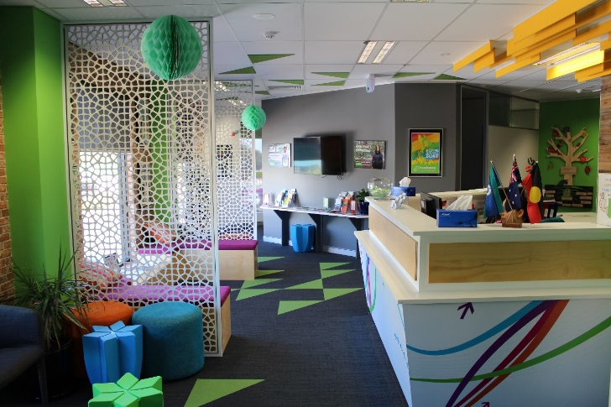
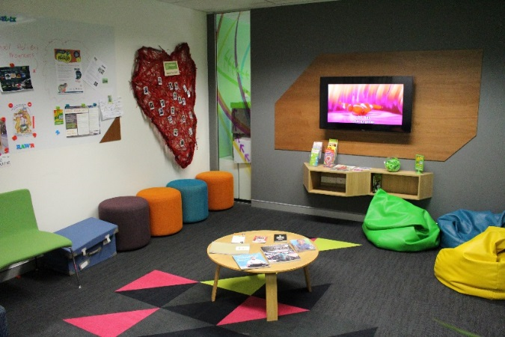
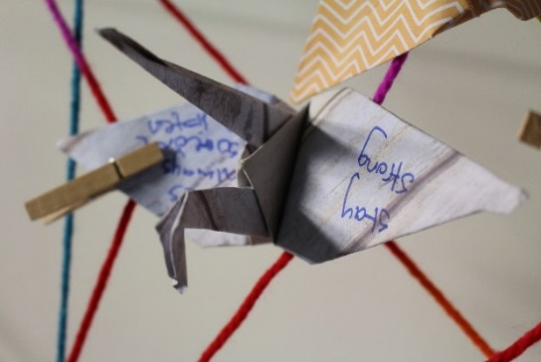

Welcome to headspace!
Hi

Contents
What is headspace? 4
Centre Operating Hours 5
Standard business hours: 5
Extended hours 5
After hours 5
What happens when you come to headspace 6
Referrals and making appointments 6
First Contact 6
Waiting times 6
The first visit: 6
Who are the Youth Access Clinicians? 7
Can I change clinicians? 7
What happens after my first appointment/s 7
Types of Support Pathways 8
Shared Decision Making and Youth participation 9
Consent and Confidentiality 10
If under 16: 10
If over 16: 10
Privacy and Confidentiality: 10
Self-Care: Supporting yourself in order to support others 12
Support Networks 13
Accessibility 14
Cost 14
Transport 14
Access for all 14
Reading, Writing, Speaking and Listening. 14
Everyone is welcome 15
First Aid 15
Feedback 16
Feedback to headspace Midland 16
Feedback to Headspace National 16
Client Wellbeing Survey (h.A.P.I) 17
Donations and Fundraising 18
Donation to headspace National: 18
Donation to headspace Midland: 18
Fundraising for headspace Midland: 18
Donations go towards: 18
Crisis / Emergency Contacts 19
Alternate Resources 21

What is headspace?
headspace is the National Youth Mental Health Foundation providing FREE early intervention mental health services to 12-25 year olds, along with assistance in promoting young peoples’ wellbeing.

This covers four core areas:
- mental health
- physical health
- work and study support
- alcohol and other drug services.

headspace is a good place to start if you:
- Are feeling down, stressed or can’t stop worrying
- Don’t feel like yourself anymore
- Can’t deal with school/uni/ work or are finding it difficult to concentrate
- Are feeling sick or worried about your health
- Have questions about, or want to cut down on alcohol or other drug use
- Want to talk about sexuality, gender identity or relationships
- Are having difficulties with your family or friends
- Have sexual health issues or want information about contraception
- Are being bullied, hurt or harassed
- Are worried about work or study or if you’re having money trouble
- Need someone to talk to
- Getting support can help you to keep you on track at school, study or work, and in your personal and family relationships. The sooner you get help the sooner things can begin to improve for you.

Find out more about us https://headspace.org.au/headspace-centres/midland/

Centre Operating Hours

Standard business hours:
Monday: 9:00am – 5:00pm
Tuesday: 9:00am – 5:00pm
Wednesday: 9:00am – 5:00pm
Thursday: 9:00am – 5:00pm
Friday: 9:00am – 5:00pm

Extended hours
Wednesday (by appointment only): 5:00pm – 7:00pm

After hours
Contact eheadspace through:
- Chat at eheadspace.org.au, seven days a week from 9am to 1am AEDST (Australian Eastern Standard Time)
- Call 1800 650 890, seven days a week from 9am to 1am AEDST
- Email us anytime

Please Note:
headspace Midland is not a crisis service.
For 24 hour crisis support you can contact:
Police / Ambulance / Fire: 000
Mental Health Emergency Response Line (MHERL): 1300 555 788
Lifeline: 13 11 14

What happens when you come to headspace

Referrals and making appointments
Anyone can refer a young person (aged 12 – 25) to headspace. This can be done by:
- Phone 9274 8860
- Email reception@headspacemidland.com.au
- Post 7/64 Morrison Road, Midland 6056
- Dropping into the centre 7/64 Morrison Road, Midland 6056 (lvl 1 of Gilberts Fresh Swan Valley Markets)
We are a voluntary service, it is up to the client if they wish to engage with our services.
Once the referral has been received by our Admin team, they will forward it onto one of our Duty Officers.

First Contact
The Duty Officers are just our friendly clinicans that will make contact via phone to get to know a bit about yourself. They will have an informal chat with you to assess your wants and needs. They will then book you in for a face – to – face appointment with either themselves or another worker.

Waiting times
Once initial contact is made by the client or referrer the admin team will submit the information through to the Duty Officer.
The Duty Officer usually makes contact within 1 – 2 business days.
The first face – to – face appointment is booked in for 2 – 4 weeks after referral is made.
Please note that wait times can vary, we do aim to assist you as soon as we can.

The first visit:
The first time a young person comes to headspace, they will:
- Complete a registration form
- Read through a Consent to Service form
- Complete a brief survey on an iPad that will track how the client is going each time they come in for an appointment. (see below under “client satisfaction”)
- See a Youth Access Clinician for a first face – to – face appointment (which on average will go for 60 minutes)

Who are the Youth Access Clinicians?
Our intake workers are experienced and trained mental health professionals. They have a passion in supporting and working with young people and their support networks.
The Youth Access Clinican will complete an assessment on each young person, they will ask about their wellbeing and what they want support with. If the young person feels comfortable, family members are welcome to join the appointment. Sometimes it might take more than one appointment for us to understand the young person’s wants and needs.

Can I change clinicians?
Yes, everyone works differently so its about finding the right "fit". If you don't feel like you are making a connection with the clinician you are seeing, please let us know and we can look at other clinicians that will be better suited. If you prefer to be linked in with only a female or male clinician then this is also something we can organise for you.
If you have questions around the assessment process please visit: https://headspace.org.au/health-professionals/psychosocial-assessment-interview/

What happens after my first appointment/s
- After the Youth Access Clinician has completed their assessment they will work with the young person to develop a “Support Pathway.” This may include appointments with various workers at headspace Midland, and/or other services in the community.
- The “Support Pathway” will be presented at an Intake Meeting which consist of different clinicians at the centre. This meeting is used to discuss each young person coming through to decide on whats best for the young person going forward.
- The Youth Access Clinician will then make contact to advise of the recommendations for the Support Pathway.
- If the client wishes to go with a different plan, the Support Pathway can be altered.
- As headspace is a voluntary service, if a young person chooses not to engage and attend appointments we will respect their decision.

Types of Support Pathways
- Brief intervention and problem solving with one of our qualified Allied Health Practitioners from a number of different teachings including: Psychology, Social Work, Occupational Therapy and Art Therapy. This support pathway will require a Mental Health Care Plan.
- Early intervention and supportive counselling with one of our Youth Access Clinicians
- Access to a GP and/or nurse for physical and mental health issues
- Vocational assistance
- Alcohol and other Drugs Counsellor
- Family counselling
- Participation in headspace workshops
- Referral to hYEPP (headspace Youth Early Pyschosis Program)
- Referral to another agency best suited to the young person’s/family’s needs
At times there may be a variations to the above as we understand that every person’s presentation and story is different.

Shared Decision Making and Youth participation
Engagement with headspace Midland is voluntary and based on your self-identified needs. As such, your involvement in treatment planning and delivery is a core principle of headspace Midland and there are a number of formal and informal mechanisms that will be put in place to facilitate this.

- Young people are invited, encouraged and supported to take the lead in identifying their goals and desired outcomes.

- Regular opportunities for young people, their families and carers to provide written or verbal feedback – feedback forms are available at reception and on the website

- The provision of a Suggestion Box in the headspace Midland foyer

- Opportunity for young people to take part in review meetings

All young people are informed of these processes in their Initial Assessment and throughout their involvement with headspace Midland.

All parents/carers are informed of these processes in the Family and Friends Information Pack. Other people important to the young people receiving a service from headspace Midland will be informed of the participation process as appropriate.

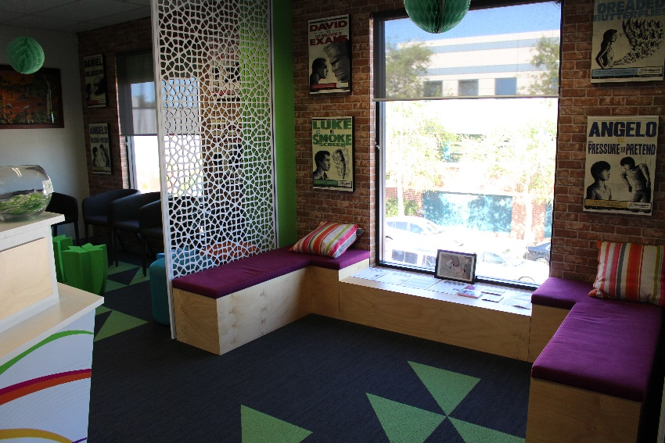

Consent and Confidentiality
headspace Midland is a voluntary organisation.
Health professionals can only carry out interventions for young people who give consent. It is therefore the young person’s decision as to whether or not they want support. Please note that this is something we will ask a young person when they attend.

We will provide the young person and their support people with enough information about the service so that they can make an informed decision about consent, confidentiality and its limits.

If under 16:
A parent or legal guardian is the appropriate person to give consent to a young person under 16 accessing our service. However in some cases these young people can consent to accessing treatment/support without parent permission. Please speak with one of our headspace team members or request a copy of our policy if you would like to know more.

If over 16:
We will work with the young person to involve family and friends in ways that they are comfortable with, and that are likely to be beneficial to the young person’s mental health.

Privacy and Confidentiality:
Confidentiality policies can be confusing but it is also really important in developing a professional relationship with young people and this will be discussed early on during the assessment phase.
We work at the pace of the young person and involve them in all the decisions that are made. We will talk about this with them and keep them informed at all times which means that what they tell us won’t be shared with anyone else unless they say so, or if duty of care applies (see below).
We have a legal and an ethical commitment to duty of care.
- If we think the young person is going to hurt themselves or someone else we can pass on information with the aim of preventing this from happening.
- If we believe that a young person is at risk of being seriously harmed by others, then we must contact the appropriate services.
- We must tell the police if the young person has committed a serious crime.
Sometimes it’s helpful for us to talk with other agencies that the young person is involved in. If this is the case, we will ask for the client’s permission to contact them.
After each session the young person has with their headspace worker, the headspace worker will write some notes on what they have talked about. These notes are kept together in a file in a secure database or if we collect anything in hard copy it is stored in such a way that no-one else has access to it unless necessary.
If you would like a copy of our Privacy Policy, please request one. If you have any questions about confidentiality, please do not hesitate to ask a headspace staff member.

Self-Care: Supporting yourself in order to support others
At headspace Midland we encourage self-care.
Worrying about someone we care about is tough, so we must remember to be kind to ourselves.
Practicing self-care enables us to best take care of the person we are supporting.
For example, a benefit of practicing this is role modelling to those who are unwell. The person you care about may be noticing how you are taking time to
de-stress and they may be encouraged to do the same.
Sometimes, taking opportunities to slow down and take a breath may naturally assist with a distressing situation, and could assist you to think more clearly about a situation.
Here’s a few ideas…
- Listen to your favourite music
- If possible, saying no when your schedule already feels too busy
- Get in touch with nature; go to the beach, head out for a walk in the bush, these places can be wonderfully quiet and energising.
- Entice the senses – eg) buy a candle that you love the smell of
- Get active eg) Yoga, swimming or gym
- If you have pets, give them a cuddle!
- Try to get a good night’s sleep
- Engaging in a hobby
- Spend time with a friend whose company you enjoy
- Practice gratitude – notice those things in life you are grateful for
- Have fun, loosen up, do something that makes you giggle
- Unplug! – phone, tv, computer
- Check in with your emotions in a space where you feel comfortable
- Remove yourself from negative people or places that can be a drain on your energy
- Soak up some sunshine
- Eat well, and drink plenty of water
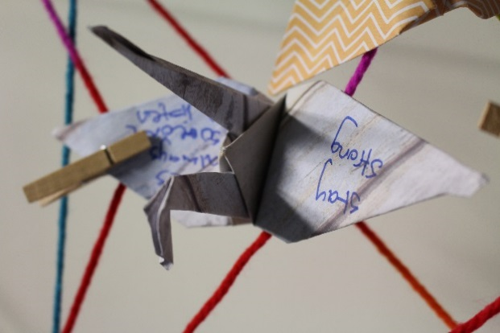

Support Networks
In trying times it is important to rally up trusted support people.
Sometimes this can help so you don’t feel alone with your worries.
Time and space in the company of those you value can do wonders. You may never know the value they have until you reach out, whether it be for a chat or even for some light relief from stressful times.
Also, consider others who may be able to assist, such as a school teacher, GP, chaplain, close family member or friend.
If talking to family or friends is tricky, you could contact support services in your area.
If you have any questions please speak with one of our Youth Access Clinicians.

Helpful suggestions
- Reinforce with yourself that the person you are worried about has their own strengths as well as others in the support network
- Take note of positive moments throughout your day, no matter how big or small
- Laugh when you can!

Accessibility

Cost
There is no fee associated with accessing any of our services at Midland headspace.
One of the support pathways is through our Allied Health Practitioners. This team includes: Clinical Psychologists, Psychologists, and Mental Health Social Workers. To access this pathway, the client is required to obtain a Mental Health Care / Treatment Plan (MHCP / MHTP) from their GP. There may be a cost associated with obtaining a MHCP, we advise that you consult with your GP if there is a cost before you make an appointment to see them. The Youth Access Worker that you will be linked in with will help support you through this process.

Transport
Parking at the Swan Valley Gilberts Fresh Markets. ACROD bays available.
Midland Train Station - less than a 10 minute walk
Outreach services might be available

Access for all
Disabled Access & Gender Neutral toilets
Elevator & stairwell access
Large waiting areas
Sensory room: weighted blankets, lamps, scented eye pillows, fidget cubes etc.
Family waiting area: bean bags, couches, toys and books

Reading, Writing, Speaking and Listening.
Translation and Interpreting Services (TIS):
Headspace Midland is registered with TIS National for translation and interpreting services
This includes:
- Immediate phone interpreting
- Pre-booked phone interpreting
- Onsite interpreting

Contact number: 131 450
Website: https://www.tisnational.gov.au/

National Relay Service:
The NRS is an Australia-wide phone service for people who are deaf or have a hearing or speech impairment.
24-hour relay call numbers
- TTY/voice calls: 133 677
- Speak & Listen: 1300 555 727
- SMS relay: 0423 677 767
- Website: https://relayservice.gov.au/about/

Headspace Midland are also able to assist with your reading and writing needs.

Everyone is welcome
headspace would like to acknowledge Aboriginal and Torres Strait Islander peoples as Australia’s First People and Traditional Custodians. We value their cultures, identities, and continuing connection to country, waters, kin and community. We pay our respects to Elders past and present and are committed to making a positive contribution to the wellbeing of Aboriginal and Torres Strait Islander young people, by providing services that are welcoming, safe, culturally appropriate and inclusive.

headspace is committed to embracing diversity and eliminating all forms of discrimination in the provision of health services. headspace welcomes all people irrespective of ethnicity, lifestyle choice, faith, sexual orientation and gender identity.

First Aid
The first aiders that are available are, Lashay on reception and Priscilla from the hYEPP team.
Please alert us at your earliest convenience if you have any allergies or first aid concerns.
Onsite Defibrillator / AED / Intelligent Public Access Defibrillator (IPAD)

Feedback
headspace is committed to providing the best possible service to young people, their family and friends. We welcome and value your feedback so we can improve the services we provide.

Feedback to headspace Midland
- Call: 9274 8860
- Email: reception@headspacemidland.com.au and title the email subject "Feedback"
- Complete the electronic feedback form by clicking https://headspacemidland.typeform.com/to/JY2yKy
- Complete the paper copy feedback form and send it through post, email or by dropping it in.
The paper copies and electronic copies of the feedback forms are also kept in reception.
Thank you, we appreciate the thought and time that goes into providing all kinds of feedback.

Feedback to Headspace National
If you would like to provide your feedback on a National Level:
Complete the feedback form here https://headspace.org.au/about-us/contact-us/ *this feedback will go directly to headspace National
headspace National Office: (03) 9027 0100

Client Wellbeing Survey (h.A.P.I)
As part of providing support, headspace will need to collect and record personal information about yourself that is relevant to your situation. The personal information will be recorded in a secure headspace database called headspace Applications Platform Interface or hAPI.
Each time the young person attends headspace, they will be asked by reception if they would like to complete a hAPI Client Wellbeing Survey on an IPAD. These surveys are voluntary so if they don't feel like completing them each time they come in, then they don't have to. The client can also choose to skip questions or sign out at any stage during the survey.
The information will be used by headspace staff in their sessions with you to help provide you with the best support possible. It will also be used by headspace National Office to evaluate, conduct research and report on how well headspace is providing health services to young people. These activities will help us understand the characteristics and needs of young people using headspace services to make our service better.
The data that is used or disclosed by headspace for evaluation, research and reporting purposes will not identify individuals. Client's names will be removed and combined with information from other young people attending headspace.
The information collected will be securely stored. Headspace staff will always ask for your permission before sharing this information with headspace National Office. If you have any questions regarding the hAPI Survey, please ask our friendly staff.

Donations and Fundraising
By making a donation to headspace you are helping us support thousands of young people across Australia.
100% of donations go towards improving the mental health and wellbeing of young people in our local community.

Donation to headspace National:
Use this link https://app.etapestry.com/bbphosted/Headspace/OnlineDonation.html?_ga=2.21254331.1230889951.1520838883-1126195618.1520567557 to complete the donation form for headspace National

Donation to headspace Midland:
Phone: (08) 9274 8860
Fax: (08) 9274 8859
Email: reception@headspacemidland.com.au
Address: Unit 7, 64 Morrison Road, Midland, Western Australia 6056 (Level 1 of Gilberts Fresh & Swan Valley Markets, Cnr of Keane St and Morrison Road)

Fundraising for headspace Midland:
If you, or someone you know is interested in fundraising for headspace Midland, then please contact us for all inquiries using the above details.

Donations go towards:
- providing presentations to your local schools & promoting our service
- purchasing merchandise and resources for young people
- funding towards workshops that are run at headspace Midland
Donations can help in a range of ways but if you would like your donations to go to a specific area or two, you can inquire about your options by contacting headspace Midland.

Crisis / Emergency Contacts
Kids Helpline: 1800 551 800 and https://kidshelpline.com.au/organisation/about-us/
• Free, 24/7 phone and online counselling service, ages 5 - 25.
Child and Adolescent Mental Health Service (CAMHS): 1800 048 636
• 24/7 phone helpline service for young people up to the age of 17 years.
Lifeline: 13 11 14 and https://www.lifelinewa.org.au/
• Free, 24/7 phone service, lifeline is for all Australians.
• https://www.lifeline.org.au/get-help/online-services/crisis-chat online chat available from 7pm – 4:00am AEST (Sydney time zone)
Crisis Care: 1800 199 008 or 9223 1111
• 24/7 phone helpline service
• Prioritises’ child protection, family and domestic violence, suicidal ideation and homelessness.
Suicide Callback Service: 1300 659 467
• Free, 24/7, for all Australians https://www.suicidecallbackservice.org.au/
• Phone, online and video chat options
Mental Health Emergency Response Line (MHERL):1300 555 788 or 1800 676 822 (PEEL)
• 24/7 phone service for all Australians
• Free call (PEEL region) 1800 676 822
Police / Ambulance / Fire: 000
• Free, 24/7, service for everyone
Local Police: 131 444
Womens Domestic Violence Hotline: 1800 007 339
Mens Domestic Violence Helpline: 1800 000 599
Sexual Assault Resource Centre (SARC): 1800 199 888
- SARC has GPs as well as counsellors. Based in Subi but they do have a base @ Womens Health Care Place in Midland
DCP (Department Child Protection) 1800 622 258
- if a child / young person is at current / imminent risk or needs accommodation / food etc
St John of God Hospital: 9462 4000 Address: 1 Clayton St, Midland WA 6056
• https://www.sjog.org.au/our-locations/st-john-of-god-midland-public-hospital-1/our-services/emergency-department
• Free emergency service, Open 24/7, service for everyone, they provide an assessment report.
• Mental health wing for voluntary and involuntary clients.
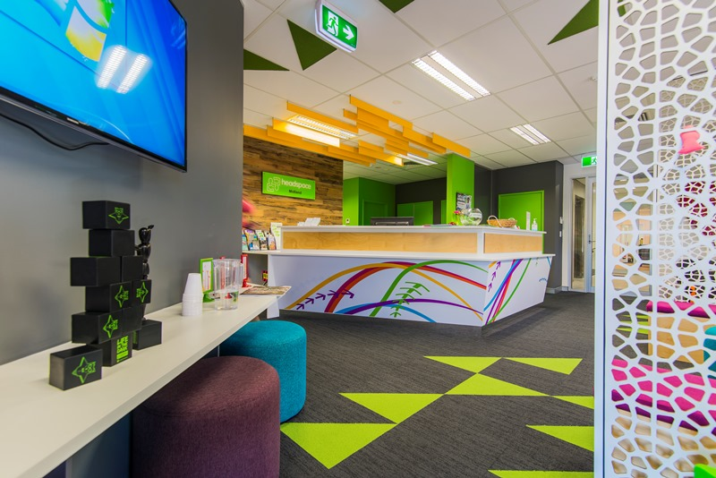

Alternate Resources
Our website has some useful links and resources
https://headspace.org.au/headspace-centres/midland/
Headspace Digital Work and Study: 1800 810 794
- Free service for 15 – 24
- https://headspace.org.au/young-people/digital-work-and-study-program/
- The digital work and study service can assist you with creating a winning resume, career planning, job searching, interview preparation, contact and collaboration with employers and social firms. We can work with your employment consultant and assist you with navigating the Centrelink labyrinth. We can support you in exploring suitable education options, assist you with getting into study, as well as sourcing financial support for your education.
Eheadspace: 1800 650 890
- Free service for 12 -25 year olds.
- https://eheadspace.org.au/
- Run Q headspace chat centre for LGBTIQ+ https://eheadspace.org.au/get-help/qheadspace/
Rise Community Network: Ph: (08) 6274 3700 – Address: 41a Great Northern Highway Middle Swan 6056 Western Australia
- Free service, for all ages
- Experience in: helping people find a home and importantly, keep that home. Social Connection, Education and Occupation, Daily Living, Health & Well-Being, Finances, Mental Health – Housing, Interests and Talents and Group Activities
- For more information http://www.risenetwork.com.au/our-services/mental-health/
Skillhire: Ph: 0447 854 758 (Aaron) or 0419 268 430 (Kairi) – Address: 8-12 Stafford Street, Midland WA 6056
- Free employment service
- Young people and adults
- Referrals to and from headspace Midland
- For more information: https://www.skillhire.com.au/
Indigo Junction: Admin Ph: (08) 9274 5382, Youth Service Ph: (08) 9274 1611, Family Service Ph: (08) 9250 5256 – Address: 53 Great Northern Hwy, Midland, WA 6056
- Free service
- Available to youths, families and the local community in the north-eastern suburbs of Perth
- Experience in:
  - Offering safe, secure and affordable housing
  - Using client-led case management strategies to give clear direction and a future focus to all our work.
  - Independent living skills training.
  - Offering a range of integrated services such as financial literacy and work readiness programs.
  - Supporting people to access specialist therapeutic service as required
- For more information: http://indigojunction.org.au/
Swan City Youth Service (Scys): Ph: (08) 9274 3488 – Address: 12 Padbury Terrace, Midland WA 6056
- Free service
- 12-25 year olds
- Works closely with Department of Child Protection and Family Services
- Experience in: educational, recreational, art and music, life skill
programs and a range of services.
- For more information: http://www.scys.com.au/
Horizon House: P: 6103 5686 – Email: HorizonHouse@sjog.org.au
- Age Group 16 – 22 years
- Provide support to young people who are currently experiencing or as serious risk of homelessness.
- Young Mother and Baby Program – provides accommodation and support to vulnerable young mothers, assist in taking their pregnancy to term and develop essential life skills that will enable time to transition to independent living. Also provides outreach support.
Freedom Centre: P: 9228 0354 | (during session times) office phone: (08) 9482 0000 | (during business hours; WA AIDS Council number) 93 Brisbane St. Northbridge PERTH 6000
- Age group: Under 26’s
- For young people to support each other and their communities to be informed, happy and healthy about their sexuality, sex and gender. Our drop-in centre is a safe space to hang out, have fun, meet other LGBTIQ young people and get peer-support and info.
- http://www.freedom.org.au/index.php?option=com_contact&view=contact&id=1&Itemid=65
Reachout
- https://au.reachout.com/
- Information and inspiring stories for young people facing difficulties
Beyondblue
- 1300 224 636
- https://www.beyondblue.org.au/
- Support and information about mental health and heaps of other stuff.
- They have online chat/phone support too
- https://www.beyondblue.org.au/who-does-it-affect/men
- Dr Ironwood and Davo’s man therapy – funny interactive sites
Qlife
- 1800 184 527
- https://qlife.org.au/
- Counselling and referral service for people who are lesbian, gay, bisexual, trans, and/or intersex (LGBTI)
Helping Minds
- https://helpingminds.org.au/
- 1800 811 747 or 9427 7100
Free support/counselling for those caring for someone with mental health concerns
Parenting WA
- 1800 654 432
- Free service to parents, carers, grandparents and families with children up to 18 years
Parent Drug Information Service
- 1800 653 203
Black Dog Institute
- (02) 9382 4530
- www.blackdoginstitute.org.au
Head to Health https://headtohealth.gov.au/
- Wherever you are on your mental health journey, Head to Health (H2H) is here to help you find the information, resources, and services that most suit your needs.
Contact your local doctor (GP)
Mobile Apps
Bye
- Smiling Mind
- MindShift
- 1GiantMind
- ReachOut WorryTime App
- Headspace

