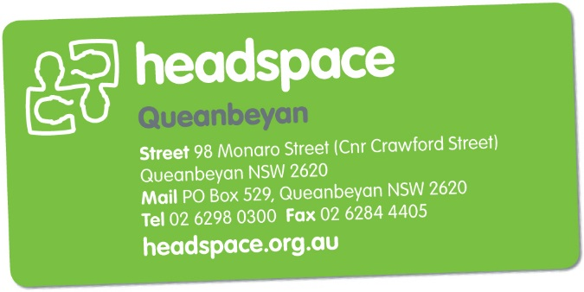

Referral Form
To be completed by services wishing to refer a young person
to headspace Queanbeyan

Referral Criteria and Guidance
headspace Queanbeyan is a free, youth-friendly and confidential service available to young people aged 12-25 years, in the Queanbeyan and surrounding area. The services available at headspace Queanbeyan include:

- Youth Friendly GPs | - Counselling
- Alcohol & Drug Support | - Vocational support
- Psychologist services (under a GP Mental Health Treatment Plan)

headspace Queanbeyan work with young people experiencing mild to moderate mental health issues such as stress, anxiety, depression or grief.

headspace Queanbeyan is not an acute mental health / crisis service. If you have any immediate concerns regarding the safety of a young person, please call:

- NSW Mental Health Line | 1800 011 511
- ACT Crisis Assessment & Treatment Team (CATT) | 1800 629 354
- Kids Helpline | 1800 551 800
- Emergency services | 000

Please return the completed referral form to:
headspace Queanbeyan | Phone: 02 6298 0300
98 Monaro Street (Corner Crawford Street) | Fax: 02 6284 4405
Queanbeyan NSW 2620

Self-Referral
Young people can refer themselves to headspace Queanbeyan. Young people are encouraged to contact headspace Queanbeyan directly by either phoning, emailing or walk-in to the centre.

Family and Friend Referral
Family, carers and friends can refer a young person to headspace Queanbeyan. Please contact headspace Queanbeyan directly by either phoning, emailing or walk-in to the centre.

Young Persons Details
Has the young person consented to this referral? Yes No
Name
Address
Date of Birth
Phone Number
Gender | Female Male Transgender Other:
Cultural Identity | Aboriginal or Torres Strait Islander CALD

Referring Service Details
Date of Referral
Name
Address
Organisation
Position in Organisation
Phone Number
Email

Reason for Referral:
Please include any information which may be useful to assist with the referral (e.g. mental health, drug and alcohol, vocational / educational or physical health including past / current risk assessments).

Does the young person have an existing GP? | Yes | No | Unsure
If yes, please detail:

Does the young person have an existing  Mental Health Treatment Plan? | Yes | No | Unsure
Does the young person require an interpreter? | Yes | No | Unsure

